





Project Report

On

**FACE RECOGNITION ATTENDANCE SYSTEM**

Course Title: Image Processing Lab

Course Code: CSE-420

**Submitted To**

**Samrat Kumar Dey**

Assistant Professor

Department of CSE

Dhaka International University

**Submitted By**

|  |  |  |  |
| --- | --- | --- | --- |
| **Name** | **Roll No.** | **Registration** | **Batch** |
| **Rabia Basree** | 16 | 103187 | D-41st |
| **Saima Yesmin** | 28 | 103381 | D-41st |
| **MD. Anwar Hossain** | 35 | 103446 | D-41st |

**Date of Submission: 23 August, 2020**

**Abstract**

Uniqueness or individuality of an individual face is the representation of one’s identity. In this project face of an individual is used for the purpose of attendance making automatically. Attendance of the student is very important for every college, universities and school. Conventional methodology for taking attendance is by calling the name or roll number of the student and the attendance is recorded. Time consumption for this purpose is an important point of concern. Assume that the duration for one subject is around 60 minutes or 1 hour & to record attendance takes 5 to 10 minutes. For every tutor this is consumption of time. To stay away from these losses, an automatic process is used in this project which is based on image processing. In this project face detection and face recognition is used. Face detection is used to locate the position of face region and face recognition is used for marking the understudy’s attendance. The database of all the students in the class is stored and when the face of the individual student matches with one of the faces stored in the database then the attendance is recorded.

**Table of Contents**

|  |  |  |
| --- | --- | --- |
| **SL.No.** | **Content Name** | **Page No.** |
| **1** | Introduction | 4 |
| **1.1** | Problem Statement | 4 |
| **1.2** | Aims and Objectives | 5 |
| **1.3** | Flow Chart | 6 |
| **1.4** | Scope of the project | 7 |
| **2** | Model Implementation & Analysis | 7 |
| **3** | Design Requirements | 8 |
| **3.1** | Software Implementation | 8 |
| **4** | Output | 10 |
| **5** | Attendance Registering | 13 |
| **6** | Conclusions | 15 |
| **7** | References | 16 |

1. **Introduction**

Attendance is prime important for both the teacher and student of an educational organization. So it is very important to keep record of the attendance. The problem arises when we think about the traditional process of taking attendance in class room. Calling name or roll number of the student for attendance is not only a problem of time consumption but also it needs energy. So an automatic attendance system can solve all above problems.

This project introduces an involuntary attendance marking system, devoid of any kind of interference with the normal teaching procedure. The system can be also implemented during exam sessions or in other teaching activities where attendance is highly essential. This system eliminates classical student identification such as calling name of the student, or checking respective identification cards of the student, which can not only interfere with the ongoing teaching process, but also can be stressful for students during examination sessions.

In addition, the students have to register in the database to be recognized. The enrolment can be done on the spot through the user-friendly interface.

**1.1. Problem Statement**

Traditional student attendance marking technique is often facing a lot of trouble. The face recognition student attendance system emphasizes its simplicity by eliminating classical student attendance marking technique such as calling student names or checking respective identification cards. There are not only disturbing the teaching process but also causes distraction for students during exam sessions. Apart from calling names, attendance sheet is passed around the classroom during the lecture sessions. The lecture class especially the class with a large number of students might find it difficult to have the attendance sheet being passed around the class. Thus, face recognition attendance system is proposed in order to replace the manual signing of the presence of students which are burdensome and causes students get distracted in order to sign for their attendance. Furthermore, the face recognition based automated student attendance system able to overcome the problem of fraudulent approach and lecturers does not have to count the number of students several times to ensure the presence of the students.

Hence, there is a need to develop a real time operating student attendance system which means the identification process must be done within defined time constraints to prevent omission. The extracted features from facial images which represent the identity of the students have to be consistent towards a change in background, illumination, pose and expression. High accuracy and fast computation time will be the evaluation points of the performance.

**1.2. Aims and Objectives**

The objective of this project is to develop face recognition attendance system. Expected achievements in order to fulfill the objectives are:

* To detect the face segment from the video frame.
* To extract the useful features from the face detected.
* To classify the features in order to recognize the face detected.
* To record the attendance of the identified student.

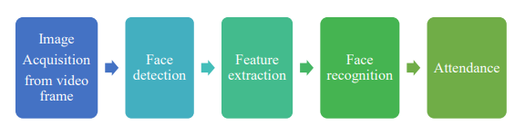

Fig: Block Diagram of the General Framework

**1.3. Flow Chart**

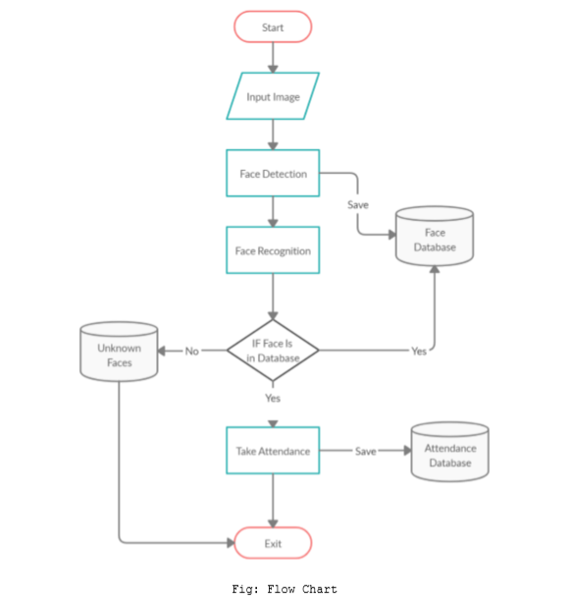

**1.4. Scope of the project**

We are setting up to design a system comprising of two modules. The first module (face detector) is a mobile component, which is basically a camera application that captures student faces and stores them in a file using computer vision face detection algorithms and face extraction techniques. The second module is a desktop application that does face recognition of the captured images (faces) in the file, marks the students register and then stores the results in a database for future analysis.

1. **Model Implementation & Analysis**

Face detection involves separating image windows into two classes; one containing faces (turning the background (clutter). It is difficult because although commonalities exist between faces, they can vary considerably in terms of age, skin color and facial expression.

The problem is further complicated by differing lighting conditions, image qualities and geometries, as well as the possibility of partial occlusion and disguise. An ideal face detector would therefore be able to detect the presence of any face under any set of lighting conditions, upon any background.

The face detection task can be broken down into two steps. The first step is a classification task that takes some arbitrary image as input and outputs a binary value of yes or no, indicating whether there are any faces present in the image. The second step is the face localization task that aims to take an image as input and output the location of any face or faces within that image as some bounding box with (x, y, width, height).After taking the picture the system will compare the equality of the pictures in its database and give the most related result.

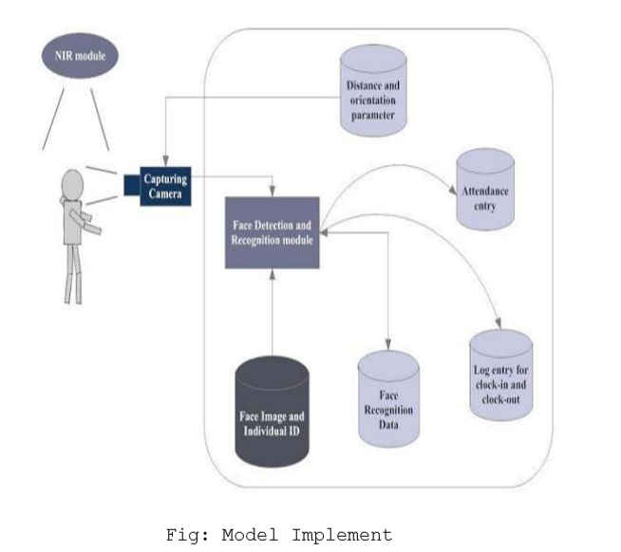

The main components used in the implementation approach are open source computer vision library (OpenCV). One of OpenCV’s goals is to provide a simple-to-use computer vision infrastructure that helps people build fairly sophisticated vision applications quickly. OpenCV library contains over 500 functions that span many areas in vision. The primary technology behind Face recognition is OpenCV. The user stands in front of the camera keeping a minimum distance of 50cm and his image is taken as an input. The frontal face is extracted from the image then converted to gray scale and stored.

1. **Design Requirements**

We used some tools to build the HFR system. Without the help of these tools it would not be possible to make it done. Here we will discuss about the most important one.

**3.1. Software & Hardware Implementation**

Build With –

* Python 3.7

Module Used -

All The Module are Latest Version.

* OpenCV Contrib 4.0.1
* Pillow
* Numpy
* Pandas
* Shutil
* CSV

Face Recognition Algorithms -

* Haar Cascade
* LBPH (Local Binary Pattern Histogram)

Software Used -

* Pycharm 2019.2

Hardware Used –

* Webcam

1. **Output**

Initial output:

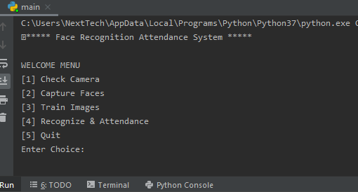

Fig: Welcome Menu

If enter choice [1]:

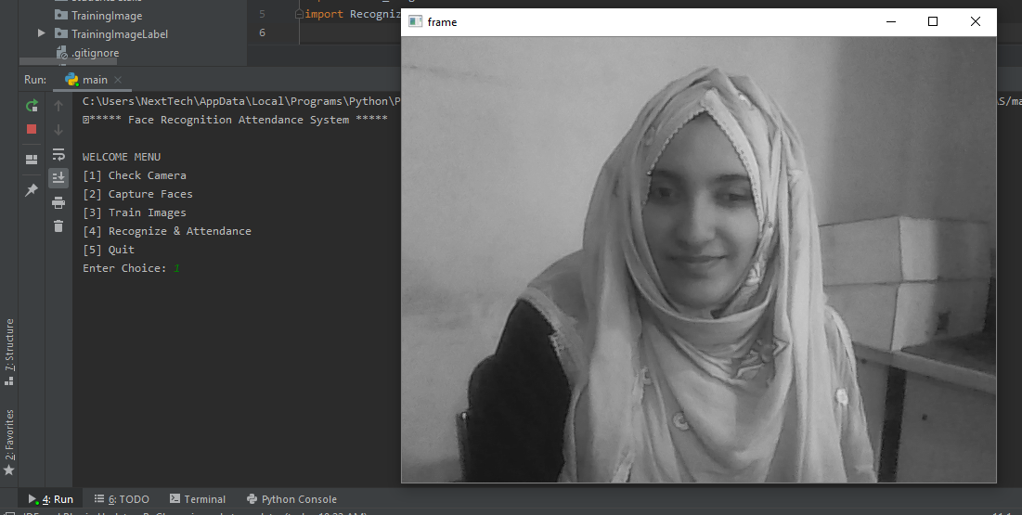

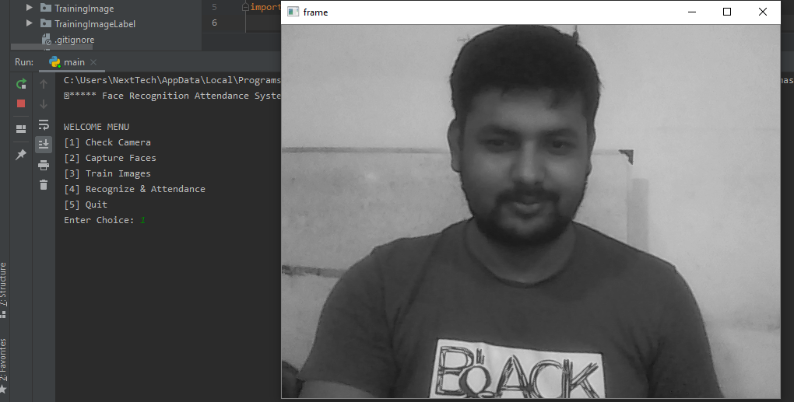

Fig: Checking Camera

If enter choice [2]:

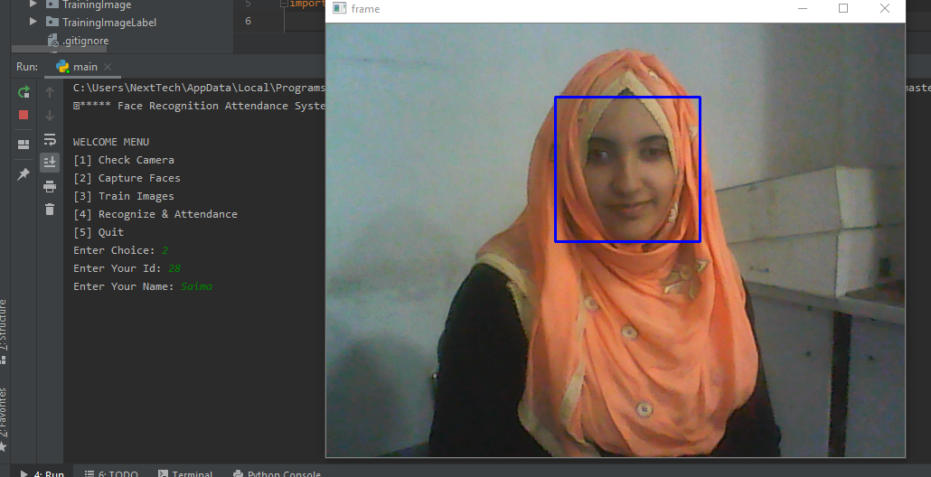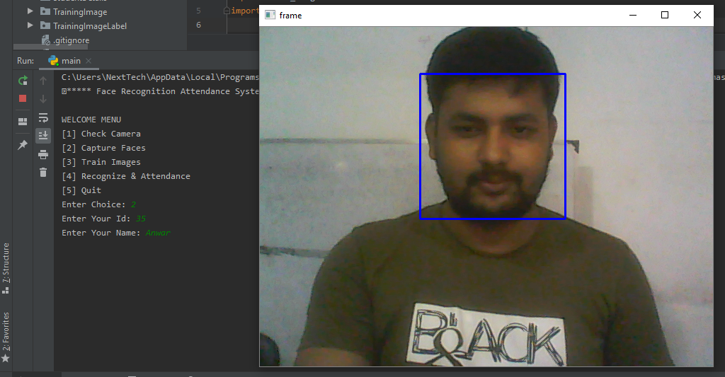

Fig: Capturing Face

If enter choice [3]:

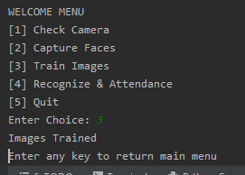

Fig: Images trained

If enter choice [4]:

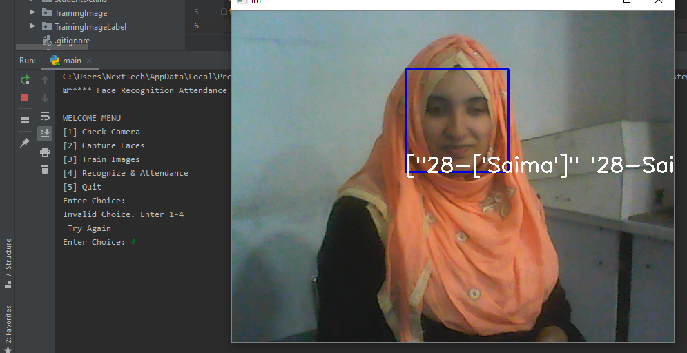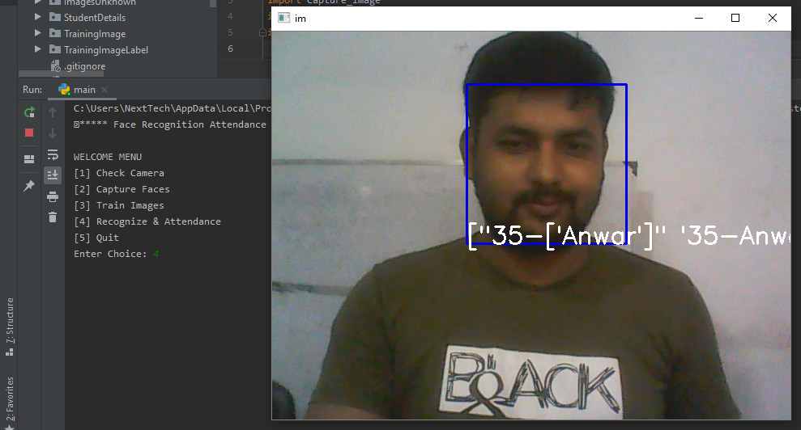

Fig: Recognition & Attendence

If enter choice [5]:

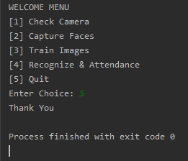

Fig: Exit

**5. Attendance Registering**

Class attendance is very important aspects for the students studying in the colleges or schools. For an organization to be successful, it needs precise and quick method for recording the performance of the individuals inside this organization. Attendance gives the data of the individual whether that particular person is physically present or absent. The traditional method of calling roll number or name of the student for marking attendance is time consuming or wastage of time during the class hour. In this project an automated student attendance system is made, which is based on face recognition. The recognized face of the individual is used for marking the attendance.

**Software Directory for Attendance Information:**

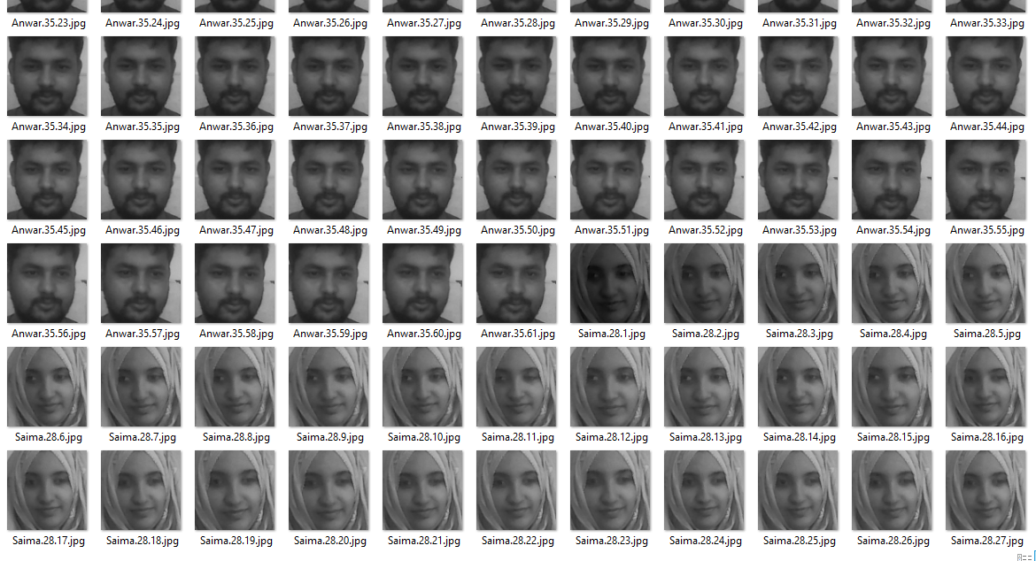

Fig: Training Image for Face Detecting

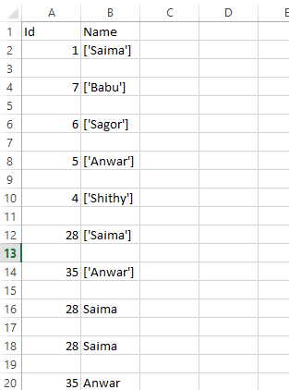

Fig: Collect Student Information

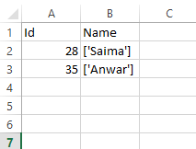

Fig: Recognize Students Attendance

1. **Conclusions**

The purpose of reducing the errors that occur in the traditional attendance taking system has been achieved by implementing this automated attendance system. In this paper, face recognition system have been presented using deep learning which exhibits robustness towards recognition of the users with accuracy of 98.3%. The result shows the capability of the system to cope with the change in posing and projection of faces. From face recognition with deep learning, it has been determined that during face detection, the problem of illumination is solved as the original image is turned into a HOG representation that captures the major features of the image regardless of image brightness. In the face recognition method, local facial landmarks are considered for further processing. After which faces are encoded which generates 128 measurements of the captured face and the optimal face recognition is done by finding the person’s name from the encoding. The result is then used to generate an excel sheet, the pdf of which is sent to the students and professors on weekly interval. This system is convenient to the user and it gives better security.

1. **References:**
2. *B.K.P. Horn and M. Brooks, Seeing Shape from Shading. Cambridge, Mass.: MIT Press, 1989.*
3. *A.F. Abate, M. Nappi, D. Riccio, and G. Sabatino, "2D and 3D face recognition: A survey", Pattern Recognition Letters, vol.28, issue 15, pp.1885-1906, Oct 2007.*
4. [*https://www.ijedr.org/papers/IJEDR1903093.pdf*](https://www.ijedr.org/papers/IJEDR1903093.pdf)
5. [*http://ethesis.nitrkl.ac.in/7301/1/AUTOMATED_Mallik_2015.pdf*](http://ethesis.nitrkl.ac.in/7301/1/AUTOMATED_Mallik_2015.pdf)
6. [*http://eprints.utar.edu.my/2832/1/EE-2018-1303261-1.pdf*](http://eprints.utar.edu.my/2832/1/EE-2018-1303261-1.pdf)
7. [*http://www.kscst.iisc.ernet.in/spp/39_series/SPP39S/02_Exhibition_Projects/184_39S_BE_1465.pdf*](http://www.kscst.iisc.ernet.in/spp/39_series/SPP39S/02_Exhibition_Projects/184_39S_BE_1465.pdf)